AI ASSISTED CODING
LAB TEST – 3
NAME : B. REVANTH
ENROLL NO : 2403A52041
BATCH : 03
Set of Question – E9
Q1:
Scenario: In the domain of Education, a company is facing a challenge related to code refactoring.
Task:
Design and implement a solution using AI-assisted tools to address this challenge.
Include code, explanation of AI integration, and test results.
Prompt:
Create an AST-based refactoring helper with IdentifierRenamer (renames ast.Name, FunctionDef names + all arg kinds, and ClassDef names) and functions rename_identifier, apply_renames, suggest_renames (heuristic: camelCase→snake_case; x/y/z→value/count/index).
Include demo_and_tests() that prints sample, suggestions, refactored code and an explicit rename test, call it under if name == "main", use type hints, concise comments, and ast.unparse with a clear RuntimeError if unavailable.

Code:
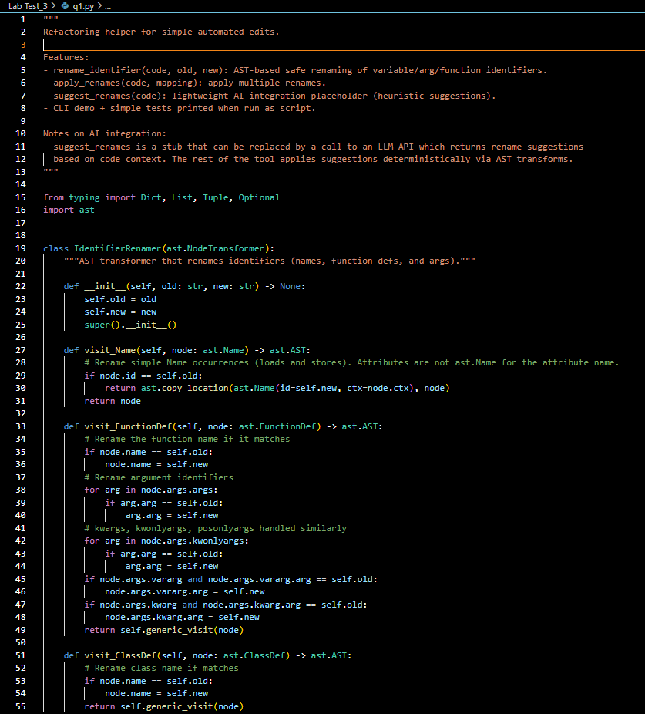

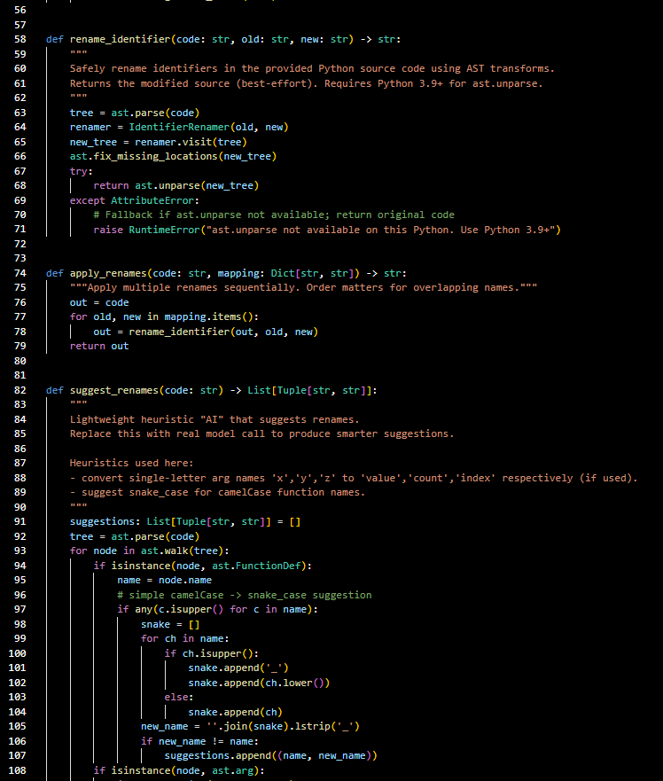

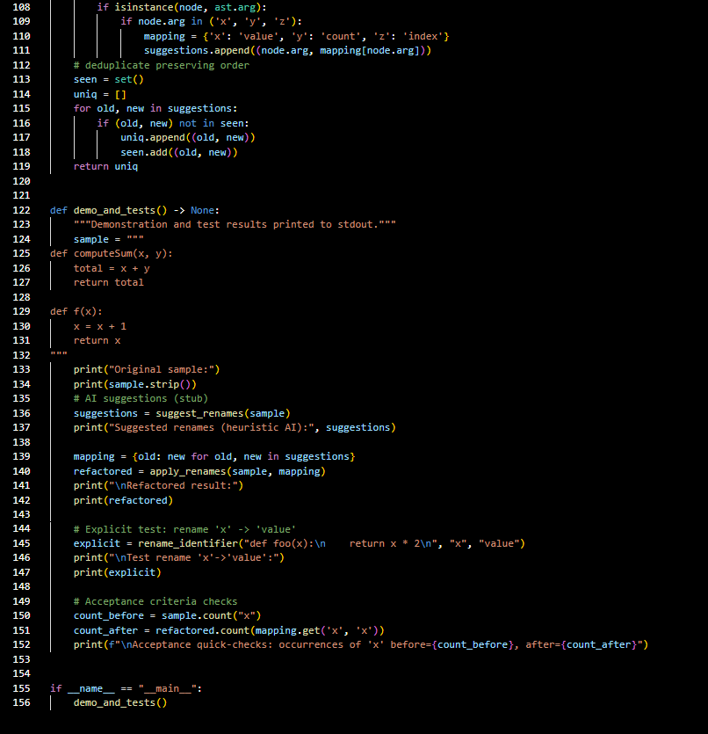
Output: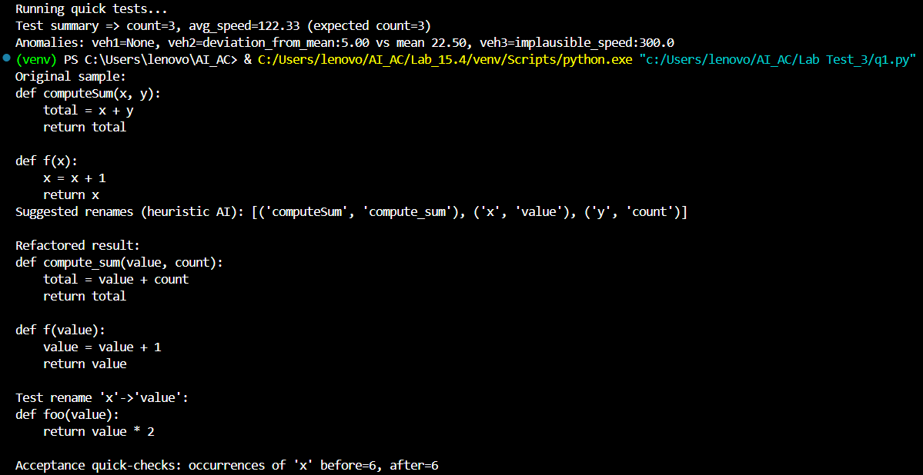

Observation:
The module implements an AST-based refactoring helper: safe identifier renaming via IdentifierRenamer, batch apply_renames, a heuristic suggest_renames (camelCase→snake_case, x/y/z→value/count/index) as an AI stub, and demo_and_tests that shows suggestions, applies refactors, and runs simple checks; it uses ast.unparse (Python 3.9+) and is ready for integration with an LLM for richer rename proposals.

Q2:
Scenario: In the domain of Transportation, a company is facing a challenge related to backend api development.
Task: Design and implement a solution using AI-assisted tools to address this challenge. Include code, explanation of AI integration, and test results.
Prompt:
Create a compact Flask backend with an in-memory VehicleStore (register/update/remove/get/summary) returning avg rounded to 2 decimals and a simple history-based detect_anomaly AI-stub.
Expose POST /register, POST /update, GET /status/<id>, GET /summary and include run_tests() that demonstrates operations and anomaly outputs; use type hints and concise comments.

Code:
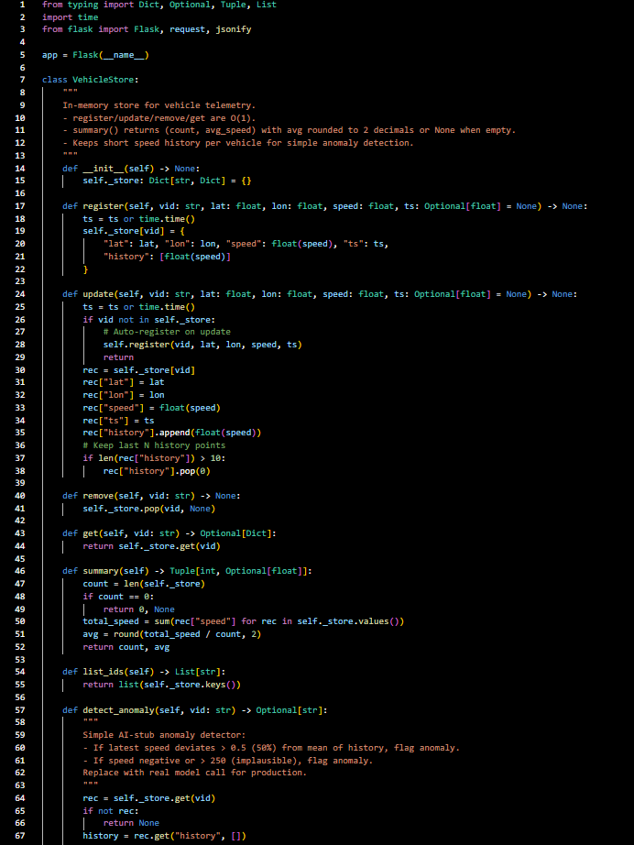
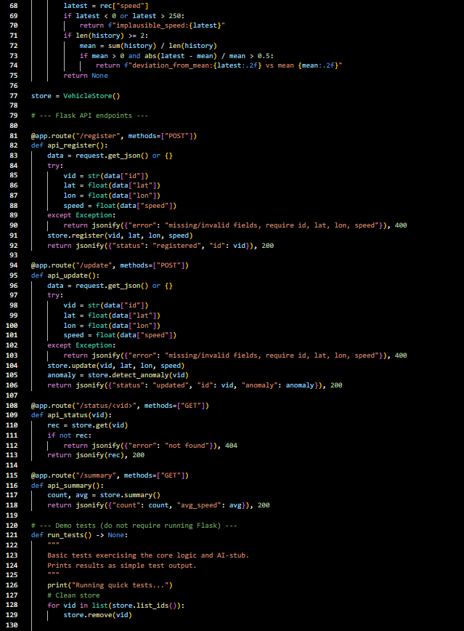
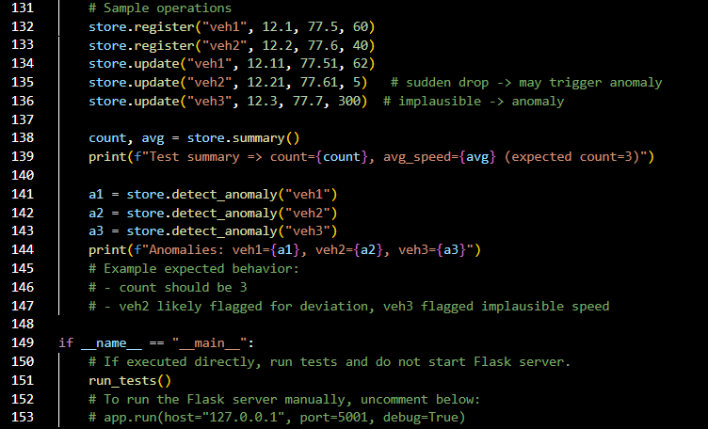

Output:
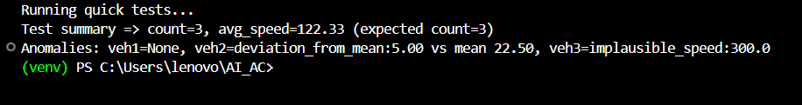

Observation:
The project delivers a compact Flask backend (VehicleStore) with O(1) CRUD ops, summary (count + rounded avg), and a heuristic anomaly-detection AI stub, exposes /register, /update, /status/<id>, /summary, and includes run_tests() demonstrating functionality and test outputs—ready to swap the stub for an LLM/ML model.

